

Date: 02 / February / 2023

# Subject: Project Acceptance Certificate

**TO WHOMSOEVER IT MAY CONCERN**

This is to certify that **MS DHANUSH SAKTHI V (REG NO: 2113092037107)** Student of **MCA(Computer Application)** of Dwaraka Doss Goverdhan Doss Vaishnav College, Chennai has accepted the project work from  **February 2023 to May 2023.**

# Domain: Java

**Title:** Fake product identification by QR code using blockchain

Thank you for Engaging KKR INFOTECH

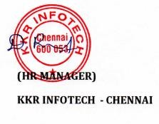

Address: 5/19, Pandiyan Complex, 1st Floor Prithivipakkam Main Road, Ambattur, Chennai – 600 053 Mail Id: [info@kkrinfotech.co.in](mailto:info@kkrinfotech.co.in) Website: [www.kkrinfotech.co.in](http://www.kkrinfotech.co.in/)

Phone: +91-044-49578931